**1**

**Write a Kotlin program to display a welcome message to the user.**

**Code**

**fun** main(args:Array<String>)

{

*println*(**"Hello World"**)

**Outout**

}

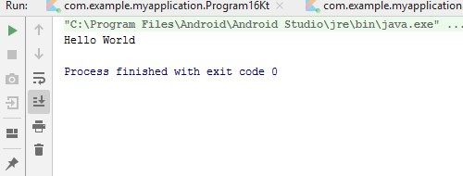

**2**

**Write a Kotlin program to store your enrollment number, name & course in different variables and display on the screen.**

**Code**

**import** java.util.Scanner

**fun** main(args:Array<String>)

{

*println*(**"Enter Enrollment_Number"**) **val** sc = Scanner(System.*`in`*) **val** Enrollment_Number = sc.nextLine()

*println*(**"Enter Name:"**)

**val** Name = sc.nextLine()

*println*(**"Enter Course:"**) **val** Course = sc.nextLine()

*println*(**"Your Enrollment_Number Is : $**Enrollment_Number**"**) *println*(**"Your Name Is : $**Name**"**) *println*(**"Your Course Is: $**Course**"**)

}

**Output**

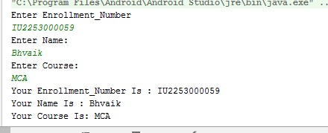

**3**

**Write a Kotlin program to accept enrollment number, student name and marks of 5 subjects, from the user. Calculate the Total and Percentage and display all the details of the student on the screen. Code**

**package** com.example.myapplication

**import** java.util.Scanner

**fun** main(args:Array<String>)

{

*println*(**"Enter Enrollment_Number:"**) **val** sc = Scanner(System.*`in`*)

**val** Enrollment_Number = sc.nextLine()

*println*(**"Enter Student_Name:"**)

**val** Student_Name =sc.nextLine()

*println*(**"Enter 5_Subject_Marks:"**)

*println*(**"Android:"**) **val** Android =sc.nextInt() *println*(**"Java:"**) **val** Java =sc.nextInt() *println*(**"Python:"**) **val** Python =sc.nextInt() *println*(**"PHP:"**)a **val** PHP =sc.nextInt() *println*(**"AngularJS:"**) **val** AngularJS =sc.nextInt()

*println*(**"Enrollment_Number: $**Enrollment_Number**"**) *println*(**"Student_Name: $**Student_Name**"**)

*println*(**"Total Marks:"** +(Android+Java+Python+PHP+AngularJS))

*println*(**"Percentage:"** + ((Android+Java+Python+PHP+AngularJS)*100/500) )

}

**Output**

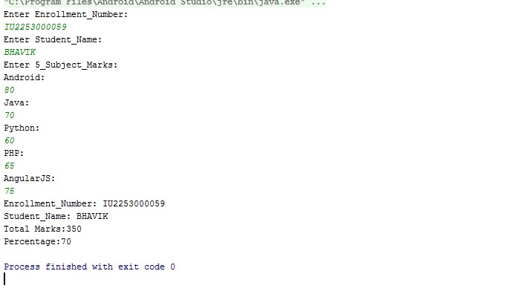

**4**

**Write a Kotlin program to perform the arithmetic operation on 2 numbers accepted from the user.**

**Code**

**package** com.example.myapplication

**import** java.util.Scanner

**fun** main(args:Array<String>)

{

**val** sc = Scanner(System.*`in`*) *println*(**"Enter The First Number: "**)

**val** a = sc.nextInt()

*println*(**"Enter the Second Number: "**)

**val** b = sc.nextInt()

*println*(**"Addition: "** + (a+b) ) *println*(**"Subtraction: "** + (a-b) ) *println*(**"Multiplication: "** + (a*b) ) *println*(**"Division: "** + (a/b) )

*println*(**"Modulo: "** + (a%b) )

}

**Output**

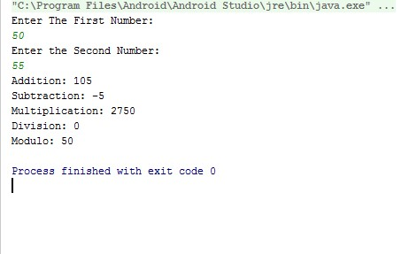

**5**

**Write a Kotlin program to calculate and display the Simple Interest. Accept the input by the user.**

{ **Code**

**package** com.example.myapplication

**import** java.util.Scanner

**fun** main(args:Array<String>)

**val** sc = Scanner(System.*`in`*) *println*(**"Enter The principal: "**)

**val** principal = sc.nextLine()

*println*(**"Enter The Rate_Of_Intrest:"**) **val** Rate_Of_Intrest = sc.nextLine()

*println*(**"Enter The Time_Period:"**)

**val** Time_Period = sc.nextLine()

*println*(**"Simple Intrest: $(Principal*Rate_Of_Intrest*Time_Period)/100"**)

}

**Output**

**6**

**Write a Kotlin program to print the multiplication table of a number.**

**Code**

**import** java.util.Scanner **fun** main(args : Array<String>)

{

**val** scanner = Scanner(System.*`in`*)

*print*(**"Enter The Multiplication Number :- "**) **val** num = scanner.nextInt()

**for** (i **in** 1..10)

{ *println*(**"${**i**} * ${**num**} = ${**i * num**}"**)

}

}

**Output**

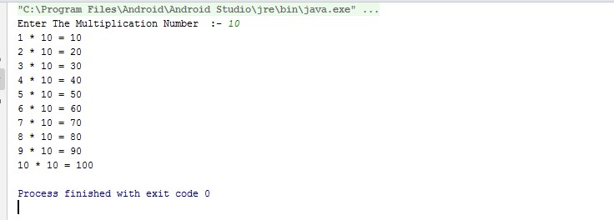

**7**

**Write a Kotlin program to calculate the area of a cylinder. Accept the radius and height from the user. Area: πr2h.**

**Code**

**package** com.example.myapplication

**import** java.util.Scanner **fun** main(args:Array<String>)

{

**val** sc = Scanner(System.*`in`*) *println*(**"Enter Redius:"**) **val** r = sc.nextInt() *println*(**"Enter Height:"**) **val** h = sc.nextInt()

**var** p1 = 3.14

**var** area = p1 * (r * r) * h *println*(**"Redius: $**r **Height: $**h **"**)

}

**Output**

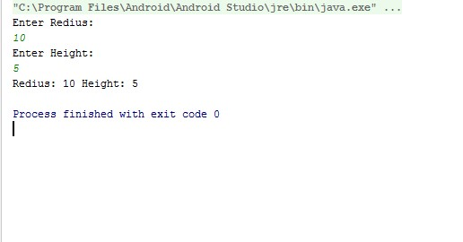

**8**

**Write a Kotlin program to demonstrate the use of mutable and immutable variables in a program.**

**Code**

**package** com.example.myapplication

**import** java.util.Scanner **fun** main(args:Array<String>)

{

**val** sc = Scanner(System.*`in`*) *println*(**"Enter The Value: "**) **val** X:Int=14 **var** Y:Int=14

*println*(**"value X: $**X **and Y: $**Y**"**)

Y=25 *//X=25*

*println*(**"value X: $**X **and Y: $**Y**"**)

}

**Output**

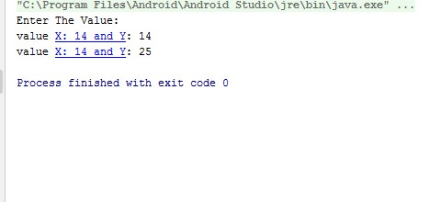

**9**

**Write a Kotlin program to find even and odd numbers between a given range. Accept the range values from the user.**

**Code**

**package** com.example.myapplication

**import** java.util.Scanner **fun** main(args:Array<String>) { **val** sc = Scanner(System.*`in`*) *println*(**"Enter The Range Number1:"**) **val** n1 = sc.nextInt()

*println*(**"Enter The Range Number2:"**) **val** n2 = sc.nextInt()

**for** (i **in** n1..n2)

{

**if** (i % 2 == 0) { *println*(**"$**i **is Even."**)

} **else** {

*println*(**"$**i **is Odd."**)

}

}

}

**Output**

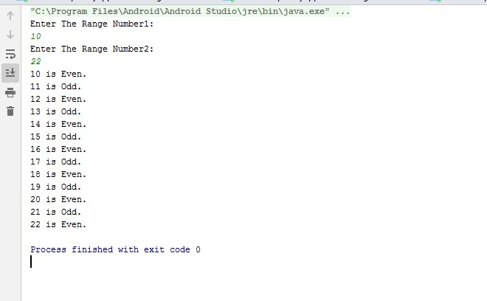

**10**

**Write a Kotlin program to accept a number from the user and check whether the number is positive, negative or zero.**

**Code**

**package** com.example.myapplication

**import** java.util.Scanner **fun** main(args:Array<String>)

{

**val** sc = Scanner(System.*`in`*) *println*(**"Enter The Multiplication_Number"**) **val** Number = sc.nextInt()

**if** (Number == 0)

{

*println*(**"${**Number**}is Zero."**)

}

**else if** (Number>0)

{

*println*(**"${**Number**}is Positive."**)

}

**else**(Number<0)

**{**

*println*(**"${**Number**}is Negative."**)

**}**

}

**Output**

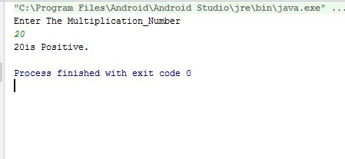

**11**

**Write a Kotlin program to make a simple calculator for +, - , *, /, %, using when.**

**Code**

**package** com.example.myapplication

**import** java.util.Scanner **fun** main(args: Array<String>)

{

**val** reader = Scanner(System.*`in`*) *print*(**"Enter two numbers: "**)

**val** first = reader.nextDouble() **val** second = reader.nextDouble()

*print*(**"Enter an operator (+, -, *, /): "**) **val** operator = reader.next()[0] **val** result: Double **when** (operator)

{

**'+'** -> result = first + second

**'-'** -> result = first - second

**'*'** -> result = first * second **'/'** -> result = first / second

**else** -> {

System.*out*.printf(**"Error! operator is not correct"**) **return**

}

}

System.*out*.printf(**"%.1f %c %.1f = %.1f"**, first, operator, second, result) }

**Output**

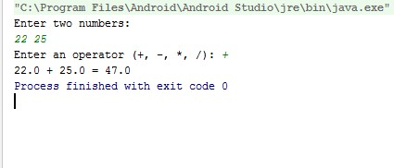

**12**

**Write a Kotlin program to swap 2 values accepted from the user without using a third variable.**

**Code**

**package** com.example.myapplication

**import** java.util.Scanner **fun** main(args : Array<String>)

{

**val** scanner = Scanner(System.*`in`*)

*print*(**"Enter The Number 1 :- "**) **var** num1 = scanner.nextInt()

*print*(**"Enter The Number 2 :- "**) **var** num2 = scanner.nextInt()

*println*(**"\nNumber 1 :- $**num1**"**) *println*(**"Number 2 :- $**num2**"**)

**var** c = 0 c = num1 num1 = num2 num2 = c

*println*(**"\nNumber 1 :- $**num1**"**) *println*(**"Number 2 :- $**num2**"**)

}

**Output**

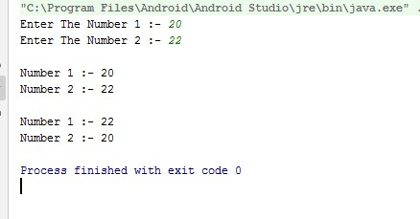

**13**

**Write a Kotlin program to find the sum of digits of a number accepted from the user.**

**Code**

**package** com.example.myapplication

**import** java.util.Scanner

**fun** getSumOfDigits(number: Int): Int

{

**var** number = number **var** sum = 0 **while** (number > 0) { **val** r = number % 10 sum += r

number /= 10

} **return** sum

}

**fun** main(arg: Array<String>)

{

**val** sc = Scanner(System.*`in`*)

*println*(**"Enter Number : "**) **val** num: Int = sc.nextInt() **val** sumOfDigits = *getSumOfDigits*(num) *println*(**"Sum of Digits : $**sumOfDigits**"**)

}

**Output**

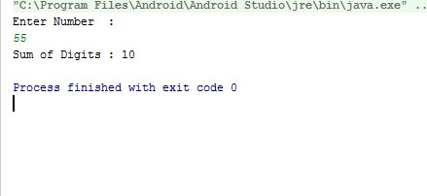

**14**

**Write a Kotlin program to accept 3 numbers from the user and print the biggest & smallest of the 3 float values.**

**Code**

**package** com.example.myapplication

**import** java.util.Scanner **fun** main(args : Array<String>)

{

**val** scanner = Scanner(System.*`in`*)

*print*(**"Enter The Number 1 :- "**) **val** n1 = scanner.nextFloat()

*print*(**"Enter The Number 2 :- "**) **val** n2 = scanner.nextFloat()

*print*(**"Enter The Number 3 :- "**) **val** n3 = scanner.nextFloat()

**if** (n1 >= n2 && n1 >= n3)

{

*println*(**"$**n1 **is the largest number."**)

}

**else if** (n2 >= n1 && n2 >= n3)

{ *println*(**"$**n2 **is the largest number."**)

} **else** {

*println*(**"$**n3 **is the largest number."**)

}

**if** (n1 <= n2 && n1 <= n3)

{

*println*(**"$**n1 **is the smallest number."**)

}

**else if** (n2 <= n1 && n2 <= n3)

{

*println*(**"$**n2 **is the smallest number."**)

} **else** {

*println*(**"$**n3 **is the smallest number."**)

}

}

**Output**

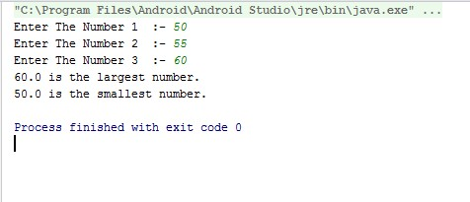

**15**

**Write a Kotlin program to accept a string from the user and count the number of vowels in it and display it to the user.**

**Code**

**package** com.example.myapplication

**import** java.util.Scanner **fun** main(args: Array<String>)

{

**var** line = **"This website is aw3som3." var** vowels = 0 **var** consonants = 0 **var** digits = 0 **var** spaces = 0

line = line.*toLowerCase*() **for** (i **in** 0..line.**length** - 1) { **val** ch = line[i] **if** (ch == **'a'** || ch == **'e'** || ch == **'i'**

|| ch == **'o'** || ch == **'u'**)

{

++vowels

}

**else if** (ch **in 'a'**..**'z'**)

{

++consonants

}

**else if** (ch **in '0'**..**'9'**)

{

++digits

}

**else if** (ch == **' '**)

{

++spaces

}

}

*println*(**"Vowels: $**vowels**"**) *println*(**"Consonants: $**consonants**"**) *println*(**"Digits: $**digits**"**) *println*(**"White spaces: $**spaces**"**)

}

**Output**

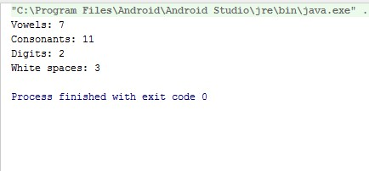

**16**

Write a Kotlin program to accept Employee Code, Employee Name, Employee Department and

Employee Basic Salary. Calculate the Gross Salary of the employee using the following criterias: **Allowance** = HRA(5% of Basic Salary) + DA(12% of Basic Salary) + TA(fixed as given below) **TA** calculation

300 - HR Dept

500 - IT Dept

800 - Sales/Marketing Dept

**Tax** as

Gross Salary <= 25,000 No Tax

Gross Salary between (26,000 & 75000) 15% Tax

Gross Salary > 75,000 25% Tax

Gross Salary = (Basic Salary + Allowance)

Net Salary = Gross salary - Tax

**Note:** Create UDF to calculate the Allowances & Net Salary

**Code**

**package** com.example.myapplication

**import** java.util.Scanner **fun** calculateAllowanceAndNetSalary(basicSalary: Double, employeeDepartment: String):

Pair<Double, Double> { *// Calculate Allowance* **val** hra = basicSalary * 0.05 **val** da = basicSalary * 0.12

**val** ta: Double = **when** (employeeDepartment) {

**"HR"** -> 300.0

**"IT"** -> 500.0

**"Sales/Marketing"** -> 800.0 **else** -> 0.0

}

**val** allowance = hra + da + ta

**val** grossSalary = basicSalary + allowance

*// Calculate Tax* **val** tax: Double = **when** { grossSalary <= 25000.0 -> 0.0

grossSalary **in** 25001.0..75000.0 -> grossSalary * 0.15 **else** -> grossSalary * 0.25

}

**val** netSalary = grossSalary - tax

**return** Pair(allowance, netSalary)

}

**fun** main(args: Array<String>) {

*// Accept input*

*println*(**"Enter Employee Code: "**) **val** employeeCode = *readLine*()!!

*println*(**"Enter Employee Name: "**) **val** employeeName = *readLine*()!!

*println*(**"Enter Employee Department: "**) **val** employeeDepartment = *readLine*()!!

*println*(**"Enter Employee Basic Salary: "**) **val** basicSalary = *readLine*()!!.*toDouble*()

**val** (allowance, netSalary) = *calculateAllowanceAndNetSalary*(basicSalary, employeeDepartment)

*// Print results*

*println*(**"Employee Code: $**employeeCode**"**) *println*(**"Employee Name: $**employeeName**"**) *println*(**"Employee Department: $**employeeDepartment**"**) *println*(**"Basic Salary: $**basicSalary**"**) *println*(**"Allowance: $**allowance**"**) *println*(**"Net Salary: $**netSalary**"**)

}

**Output**

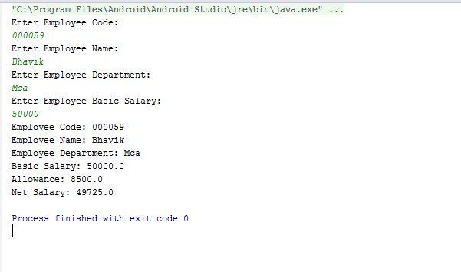

**17**

**Write a Kotlin program to input 5 numbers from the user and find their sum and average.**

**Code**

**package** com.example.myapplication

**import** java.util.Scanner **fun** main(args : Array<String>)

{

**val** scanner = Scanner(System.*`in`*)

*print*(**"Enter The Subject 1 :- "**) **val** sub1 = scanner.nextInt()

*print*(**"Enter The Subject 2 :- "**) **val** sub2 = scanner.nextInt()

*print*(**"Enter The Subject 3 :- "**) **val** sub3 = scanner.nextInt()

*print*(**"Enter The Subject 4 :- "**) **val** sub4 = scanner.nextInt()

*print*(**"Enter The Subject 5 :- "**) **val** sub5 = scanner.nextInt()

**var** total = sub1 + sub2 + sub3 + sub4 + sub5

*println*(**"Total :- $**total**"**) *println*(**"Per :- ${** total / 5.0 **} % "**)

}

**Output**

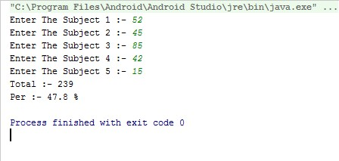

**18**

**Write a Kotlin program to print the following pattern:**

**1**

**12**

**123**

**1234**

**12345**

**123456**

**1234567**

**12345678**

**123456789**

**12345678910**

**Code**

**package** com.example.myapplication

**import** java.util.Scanner **fun** main(args : Array<String>)

{

**val** scanner = Scanner(System.*`in`*)

*print*(**"Enter The Number :- "**) **val** n = scanner.nextInt() **for** (i **in** 1..n) {

**for**(j **in** 1..i) { *print*(**"$**j **"**)

} *println*(**""**)

}

}

**Output**

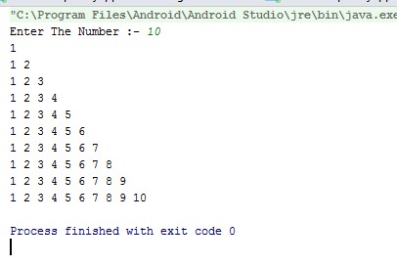

**19**

**Write a menu driven Kotlin program to provide a list of options to the user for finding Square, Cube and factorial of a number. Using when perform the appropriate operation as selected by the user.**

**Code**

**package** com.example.myapplication

**import** java.util.Scanner **fun** main(args : Array<String>)

{

**val** scanner = Scanner(System.*`in`*) loop@ **while** (**true**)

{

*println*(**"\n\n*** Select Menu ***"**) *println*(**"1. Square"**) *println*(**"2. Cube"**) *println*(**"3. Factorial"**) *println*(**"4. Exit"**)

*print*(**"Select Option :- "**) **val** ch = scanner.next()[0]

**when** (ch) {

**'1'** ->

{

*print*(**"Enter The Square Number :-"**) **val** num = scanner.nextInt()

*println*(**"Area of Square :- ${**num * num**}"**)

}

**'2'** -> {

*print*(**"Enter The Cube Number :-"**) **val** num = scanner.nextInt() *println*(**"Area of Cube :- ${**num * num * num**}"**)

}

**'3'** -> {

*print*(**"Enter The Factorial Number :-"**) **val** num = scanner.nextInt()

**var** fact=1 **for**(i **in** 1..num){ fact=fact*i;

} *println*(**"Factorial :- $**num **:- ${**fact**}"**)

}

**'4'** -> **break**@loop

**else** -> {

*println*(**"Operator is not correct"**)

}

}

}

}

**Output**

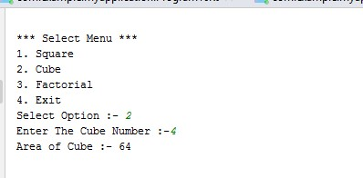

**20**

**Write a menu driven Kotlin program to provide a list of options to the user for finding the area of Circle, Square, Triangle and Cylinder. Perform appropriate operation as selected by the user.**

**Code**

**package** com.example.myapplication

**import** java.util.Scanner **fun** main(args : Array<String>) {

**val** scanner = Scanner(System.*`in`*)

loop@ **while** (**true**)

{

*println*(**"\n\n*** Select Menu ***"**) *println*(**"1. Circle"**) *println*(**"2. Square"**) *println*(**"3. Triangle"**) *println*(**"4. Cylinder"**) *println*(**"5. Exit"**)

*print*(**"Select Option :- "**) **val** ch = scanner.next()[0]

**when** (ch) {

**'1'** -> {

*print*(**"Enter The Radius Number :-"**) **val** radius = scanner.nextInt()

*println*(**"Area of Circle :- ${**3.14 * radius * radius **}"**)

}

**'2'** -> {

*print*(**"Enter The Square Number :-"**) **val** num = scanner.nextInt()

*println*(**"Area of Square :- ${**num * num**}"**)

}

**'3'** -> {

*print*(**"Enter The Base length of Triangle :-"**) **val** base = scanner.nextInt()

*print*(**"Enter The Base Height of Triangle :-"**) **val** height = scanner.nextInt()

*println*(**"Area of Triangle :- ${**0.5 * base * height**}"**)

}

**'4'** -> {

*print*(**"Enter The Radius Number :-"**) **val** radius = scanner.nextInt()

*print*(**"Enter The height Number :-"**) **val** height = scanner.nextInt()

*println*(**"Area of Cube :- ${**(22*radius*(radius+height))/7**}"**)

}

**'5'** -> **break**@loop

**else** -> {

*println*(**"Operator is not correct"**)

}

}

}

}

**Output**

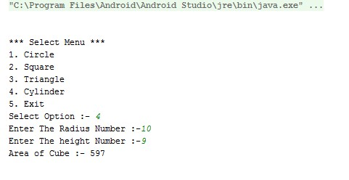

**21**

**Write a Kotlin program to print the following pattern:**

********

*******

******

*****

****

***

**

*

**Code**

**package** com.example.myapplication

**import** java.util.Scanner **fun** main(args : Array<String>)

{

**val** scanner = Scanner(System.*`in`*)

**val** rows = 8 **for** (i **in** rows *downTo* 1) { **for**(j **in** 1..i) { *print*(**"* "**)

} *println*(**""**)

}

}

**Output**

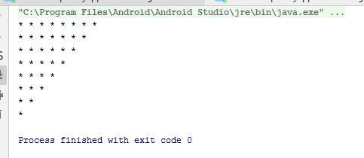

**22**

**Rewrite the program for question no. 11 using lambda.**

**Code**

**package** com.example.myapplication

**import** java.util.Scanner **fun** main(args : Array<String>)

{

**val** scanner = Scanner(System.*`in`*)

*print*(**"Enter The Number :- "**) **val** n = scanner.nextInt() **for** (i **in** n *downTo* 1) { **for**(j **in** 1..i) { *print*(**"* "**)

} *println*(**""**)

}

}

**Output**

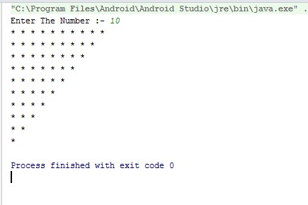

**23**

**Write a Kotlin program to accept N values from the user, and perform the addition of positive numbers only. Note: Use a do-while loop and using UDF.**

**Code**

**package** com.example.myapplication

**import** java.util.Scanner **val** *scanner* = Scanner(System.*`in`*) **fun** main(args : Array<String>)

{

**val** scanner = Scanner(System.*`in`*)

*print*(**"Enter The Number :- "**) **val** num = scanner.nextInt() **var** i = 1 **var** sum = 0

**while** (i <= num) { sum = num + num *print*(**"$**i **+ "**) i++ } *println*()

*println*(**"sum :- $**sum**"**)

}

**Output**

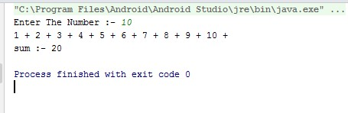

**24**

**Write a Kotlin program to create an array of 5 string values and print them using forEach loop. Also create UDF for the same.**

**Code**

**package** com.example.myapplication

**import** java.util.Scanner **fun** main(args : Array<String>)

{

**val** scanner = Scanner(System.*`in`*)

**var** names = *arrayOf*(**"BHAVIK"**, **"ABC"**, **"XYZ"**, **"PATEL"**)

names.*forEach* **{** item **->** *println*(item) **}**

}

**Output**

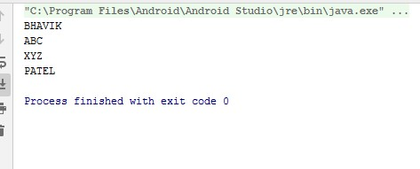

**25**

**Write a Kotlin program to print the fibonacci series having “N” elements. Accept the value of N from the user. Note:Use loop in reverse order & create UDF**

**Code**

**package** com.example.myapplication

**import** java.util.Scanner **fun** Fibonacci(n:Int):Int

{ **var** a = 0 **var** b = 1 **var** c:Int **var** i:Int

**if**( n == 0) **return** n; *print*(**"$**a **+ $**b **+"**)

**for**(i **in** 2..n)

{ c = i a = b b = c + a

*print*(**" $**b **+ "**)

} **return** b;

}

**fun** main(args: Array<String>)

{

**val** scanner = Scanner(System.*`in`*)

*print*(**"Enter The Number :- "**)

**var** num = scanner.nextInt()

*println*(**"\nfibonacci :- ${***Fibonacci*(num)**}"**) }

**Output**

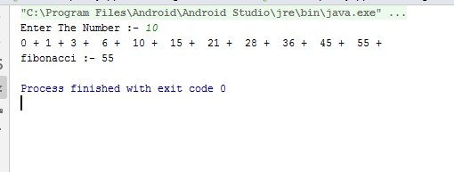

**26**

**Write a Kotlin program to convert Kilometre to Metres or vice versa. Accept the choice from the user and perform the conversion accordingly. Note: Try to use lambda function for conversion**

**Code**

**package** com.example.myapplication

**import** java.util.Scanner **fun** main(args: Array<String>)

{

**val** scanner = Scanner(System.*`in`*) *print*(**"Enter The kilometers :- "**) **var** kilometers = scanner.nextFloat() **var** conv_fac = 0.621371 **var** miles = kilometers * conv_fac

*println*(**"${**String.*format*(**"%.2f"**, kilometers)**} kilometers is equal to**

**${**String.*format*(**"%.2f"**, miles)**}"**)

}

**Output**

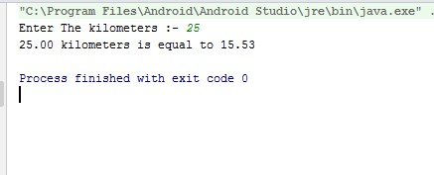

**27**

**Write a Kotlin program to print all prime numbers in between a given range, using UDF.**

**Code**

**package** com.example.myapplication

**import** java.util.Scanner **fun** main(args : Array<String>)

{

**val** scanner = Scanner(System.*`in`*)

*print*(**"Enter The Range Number 1 :- "**) **val** num1 = scanner.nextInt()

*print*(**"Enter The Range Number 2 :- "**) **val** num2 = scanner.nextInt()

}

**Output**

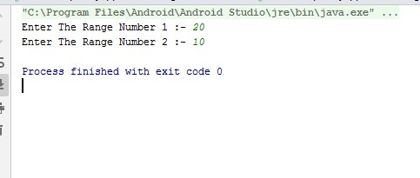

**28**

**Write a Kotlin program to accept a number from the user and check whether it is an Armstrong number or not. Note: Use do-while loop & create UDF Example: 153 is an Armstrong number because (13)+(53)+(33) = 153.**

**Code**

**package** com.example.myapplication

**import** java.util.Scanner **fun** Armstrong(num:Int)

{

**var** temp: Int **var** remainder: Int **var** result = 0 temp = num **while** (temp != 0)

{

remainder = temp % 10

result += Math.pow(remainder.toDouble(), 3.0).toInt() temp /= 10

}

**if** (result == num)

*println*(**"$**num **is an Armstrong number."**) **else**

*println*(**"$**num **is not an Armstrong number."**)

}

**fun** main(args: Array<String>)

{

**val** scanner = Scanner(System.*`in`*) *print*(**"Enter The Number :- "**) **var** num = scanner.nextInt() *Armstrong*(num)

}

**Output**

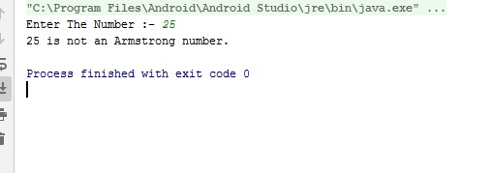

**29**

**Write a Kotlin program to demonstrate the use of indices attributes and withIndex() function of an Array**

**Code**

**package** com.example.myapplication

**import** java.util.Scanner **fun** main(args: Array<String>)

{

**val** scanner = Scanner(System.*`in`*)

**val** names = *arrayOf*(**"bhavik"**,**"xyz"**,**"abc"**,**"patel"**)

*println*(**"\nIndices Attributes"**) **for** (i **in** names.*indices*)

{ *println*(**"index :- $**i **- Name :- ${**names[i]**}"**)

}

*println*(**"\nWithIndex Function"**) **for** ((i,name ) **in** names.*withIndex*()){ *println*(**"index :- $**i **- Name :- ${**name**}"**)

}

}

**Output**

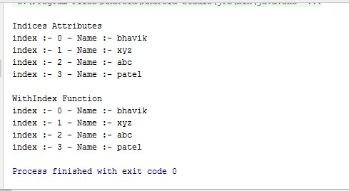

**30**

**Write a Kotlin program to accept a value from the user either between 0-6 or any 1 value from the following: { “Sun”, “Mon”,”Tue”,”Wed”,”Thurs”,”Fri”,”Sat”}. Print the full name of the day based on input received using UDF**

**Code**

**package** com.example.myapplication

**import** java.util.Scanner **fun** main(args: Array<String>)

{

*print*(**"Enter a number between 0 and 6 or a day of the week (Sun, Mon, Tue, Wed, Thurs, Fri, Sat):"**)

**var** input = *readLine*()!!.*trim*()

*println*(**"The day of the week is: ${***getDayOfWeek*(input)**}"**)

}

**fun** getDayOfWeek(input: String): String

{

**val** daysOfWeek = *arrayOf*(**"Sun"**, **"Mon"**, **"Tue"**, **"Wed"**, **"Thurs"**, **"Fri"**, **"Sat"**) **var** inputIndex = -1 **if** (input **in** daysOfWeek)

{

inputIndex = daysOfWeek.*indexOf*(input)

} **else** { **try** {

inputIndex = input.*toInt*() } **catch** (e: NumberFormatException)

{ **return "Invalid input"**

} }

**if** (inputIndex **!in** 0..6)

{ **return "Invalid input"**

}

**return when** (inputIndex)

{

1. -> **"Sunday"**
2. -> **"Monday"**
3. -> **"Tuesday"**
4. -> **"Wednesday"**
5. -> **"Thursday"**
6. -> **"Friday"**
7. -> **"Saturday" else** -> **"Invalid input"**

}

}

**Output**

